**SOP – Exception on Runtime policy.**

**Submitted to**

**By**

**Wipro Technologies**

**Revision History**

|  |  |  |  |  |
| --- | --- | --- | --- | --- |
| **Version** | **Date of Revision** | **Description of Change** | **Reason for Change** | **Reviewed By** |
| 1.1 | 28-March-24 | Initial Draft | NA | Mihirkumar |
|  |  |  |  |  |
|  |  |  |  |  |

**Author/Reviewer/Approvals**

|  |  |  |  |
| --- | --- | --- | --- |
| **Name** | **Designation** | **Responsibility** | **Date** |
| Mihirkumar Jani | Consultant | Author | 28-March-24 |
| Kannan Kuppusamy | Technical Lead | Reviewer | 29-March-24 |
| Felix Jebamani | Lead Consultant | Reviewer | 29-March-24 |
| Jamshid Abedi | Executive Director | Approver | 12-July-24 |

**Table of Contents**

**Step 1** – Go to runtime policy 2

**Step 2** – Provide exception by adding image, repository, or namespace in ‘Additional Scope Criteria’. 3

**Step 3** –Testing 3

**Scenario 1:** Image base exception 4

**Scenario 2:** Repository base exception 5

**Scenario 3:** Namespace base exception 6

**Scenario 4:** Image & Repository base exception 7

**Scenario 5:** Image & Namespace base exception 8

**Scenario 6:** Repository & Image base exception 9

**Scenario 7:** Repository & Namespace base exception 10

**Scenario 8:** Image, Repository & Namespace base exception 11

**Step 1** – Go to runtime policy (Navigating to runtime policy)

Example: Runtime Policies > control ‘Block Non-compliant Images’ with ‘Enforce’ mode

We tested on non-prod AKS cluster ‘AKS-AM-EastUS-NP-SREDO’

**Step 2** – Provide exception by adding image, repository, or namespace in ‘Additional Scope Criteria’.

Example: image, repository, or namespace

**Step 3** –Testing

Below is deployment .yaml files of namespace ‘app-one, app-two & app-three’

  

**Image details:**

**app-one:** acreastussredo.azurecr.io/elc/baseimage/php:v20220811-181627

**app-two:** acreastussredo.azurecr.io/elc/baseimage/php:v20210903-185452

**app-three:** acreastussredo.azurecr.io/elc/sre/baseimage/release/nginx/nginx_1.19-alpine:latest

**Repository details:**

**app-one:** elc/baseimage/php

**app-two:** elc/baseimage/php

**app-three:** elc/sre/baseimage/release/nginx/nginx_1.19-alpine

## **Scenario 1:** Image base exception

Excepted image: acreastussredo.azurecr.io/elc/baseimage/php:v20220811-181627 ( namespace ‘app-one’ image)

**AKS cluster output:**

Namespace ‘app-one’ container is up and running because we provided exception of the image.

But Namespace ‘app-two & app-three’ container is not come up because of Aqua policy control ‘Block Non-compliant Images’.

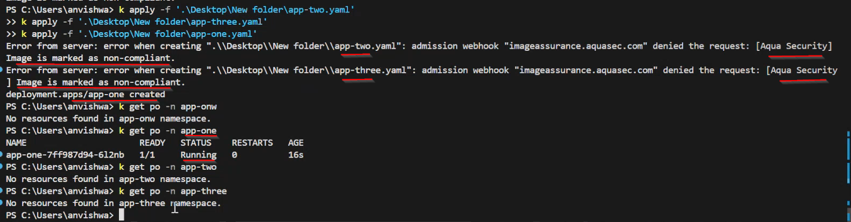

## **Scenario 2:** Repository base exception

Excepted Repository: elc/sre/baseimage/release/nginx/nginx_1.19-alpine (Repository of ‘app-three’ image)

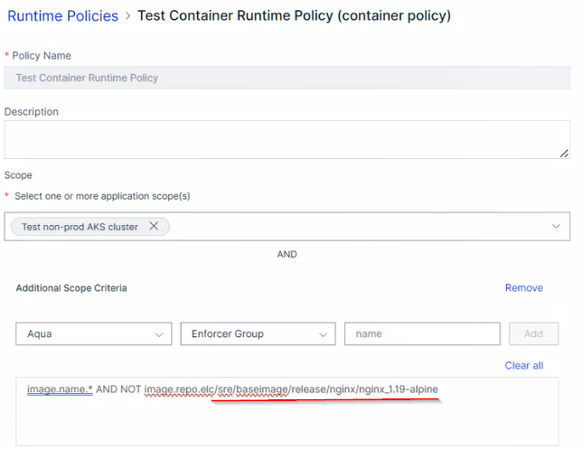

**AKS cluster output:**

Namespace ‘app-three’ container is up and running because we provided exception of the image repository.

But namespace ‘app-one & app-two’ container are not come up because of Aqua policy control ‘Block Non-compliant Images’.

## **Scenario 3:** Namespace base exception

Excepted Namespace: app-one

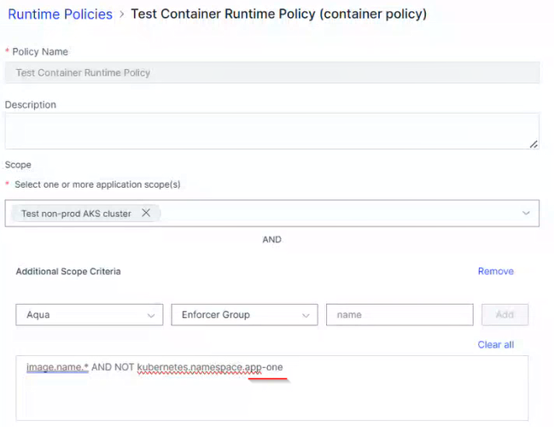

**AKS cluster output:**

Namespace ‘app-one’ container is up and running because we provided exception of the namespace.

But namespace ‘app-two & app-three’ container is not come up because of Aqua policy control ‘Block Non-compliant Images’.

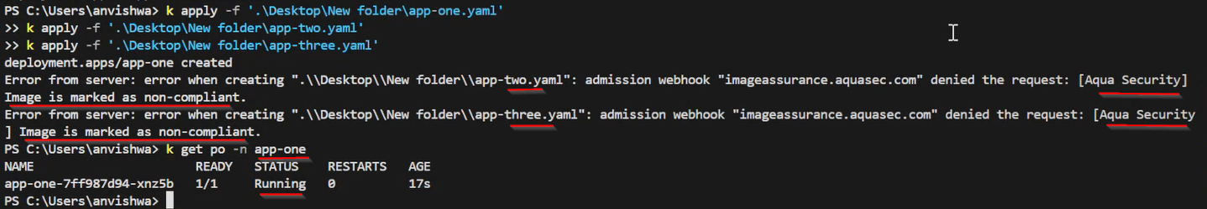

## **Scenario 4:** Image & Repository base exception

Excepted Image: acreastussredo.azurecr.io/elc/baseimage/php:v20210903-185452

Excepted Repository: elc/baseimage/php

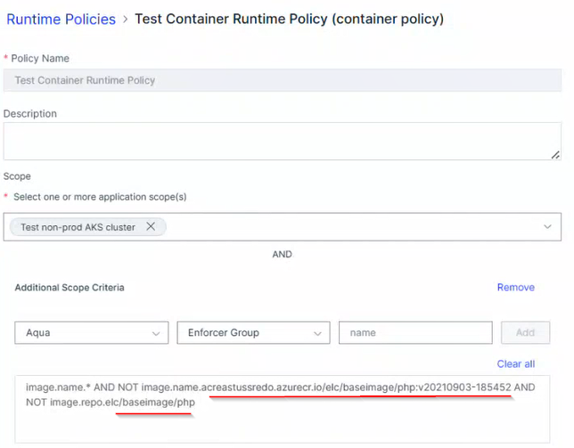

**AKS cluster output:**

Namespace ‘app-one’ container is up and running because we provided exception of the image and namespace ‘app-two’ container is up and running because we provided exception of the image repository.

But namespace ‘app-three’ container is not come up because of Aqua policy control ‘Block Non-compliant Images’.

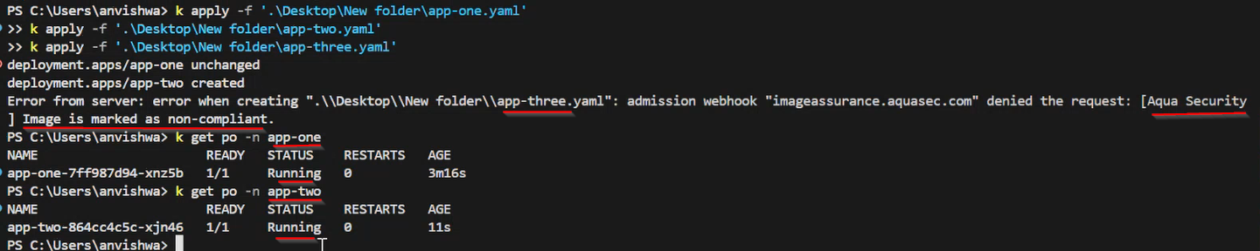

## **Scenario 5:** Image & Namespace base exception

Excepted Image: acreastussredo.azurecr.io/elc/baseimage/php:v20210903-185452

Excepted Namespace: app-three

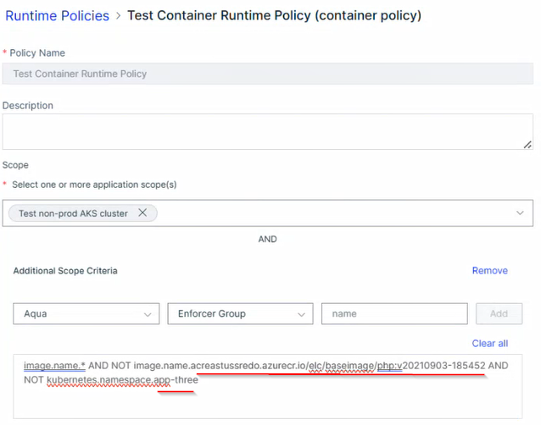

**AKS cluster output:**

Namespace ‘app-two’ container is up and running because we provided exception of the image, and namespace ‘app-three’ container is up and running because we provided exception of the namespace.

But namespace ‘app-one’ container is not come up because of Aqua policy control ‘Block Non-compliant Images’.

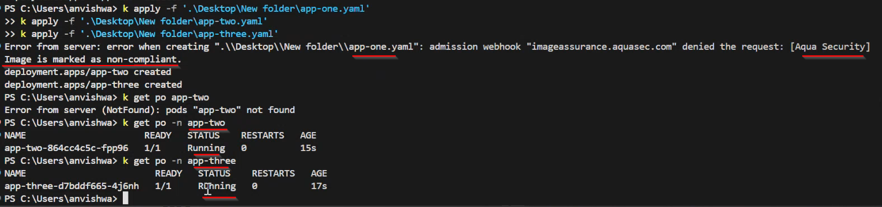

## **Scenario 6:** Repository & Image base exception

Excepted Repository: elc/sre/baseimage/release/nginx/nginx_1.19-alpine

Excepted Image: acreastussredo.azurecr.io/elc/baseimage/php:v20220811-181627

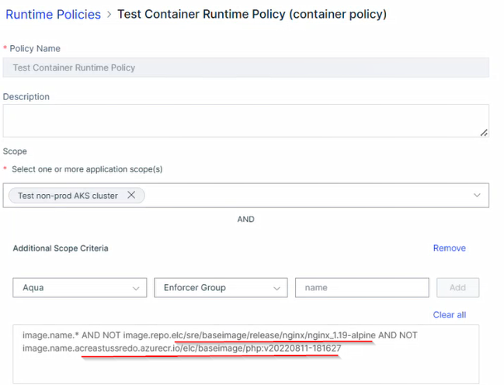

**AKS cluster output:**

Namespace ‘app-three’ container is up and running because we provided exception of the repository, and namespace ‘app-one’ container is up and running because we provided exception of the image.

But namespace ‘app-two’ container is not come up because of Aqua policy control ‘Block Non-compliant Images’.

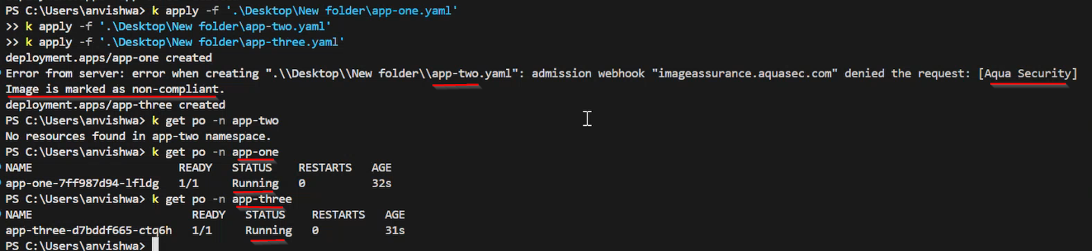

## **Scenario 7:** Repository & Namespace base exception

Excepted Repository: elc/sre/baseimage/release/nginx/nginx_1.19-alpine

Excepted namespace: app-two

**AKS cluster output:**

Namespace ‘app-three’ container is up and running because we provided exception of the repository, and namespace ‘app-two’ container is up and running because we provided exception of the namespace.

But namespace ‘app-one’ container is not come up because of Aqua policy control ‘Block Non-compliant Images’.

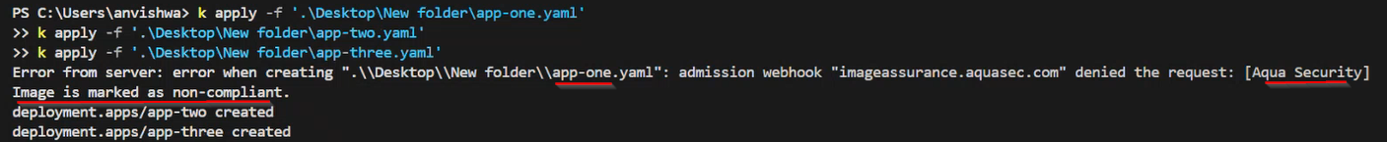

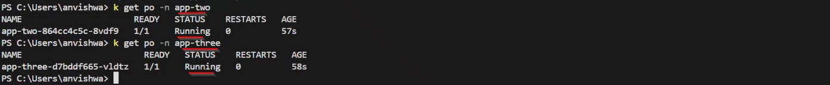

## **Scenario 8:** Image, Repository & Namespace base exception

Excepted Image: acreastussredo.azurecr.io/elc/baseimage/php:v20220811-181627

Excepted Repository: elc/sre/baseimage/release/nginx/nginx_1.19-alpine

Excepted namespace: app-two

**AKS cluster output:**

Namespace ‘app-one’ container is up and running because we provided exception of the image, namespace ‘app-three’ container is up and running because we provided exception of the repository, and namespace ‘app-two’ container is up and running because we provided exception of the namespace.

